OPC Foundation Client-Server Solution
This document contains the I+D technical details of the MVC solution that integrates Hangfire and OPC Foundation

Contents
Requirements 2
Overview 3
Scope 5
RQ-01 | MVC Hangfire Management Application 6
RQ-02 | OPC Foundation Client-Server and DB Model Layer 8
RQ-03 | OPC Foundation Core 10
Deployment 11
Software life cycle management 14
Annexes 15
Improvements and performance 15
Hangfire application always running on IIS 15
Jobs chain of responsibility pattern 15
Additional tools used for testing 15
UaExpert 15

Doc. Version | Date | Author | Description
1.0 | 2025-10-09 | Iker Elg. Alzaa | First version of the release

Requirements
The next table shows the requirements for the solution described.
Requirement | Description
RQ-001 | MVC application with Hangfire | MVC application integrating Hangfire (including a console and Windows Server project for Hangfire.
RQ-002 | OPC Foundation client-server and DB model layer | Custom client-server OPC libraries and jobs, as well as the model and database access.
RQ-003 | OPC Foundation core | Projects with the source code containing the SDK & Stack of OPC Foundation.

Overview
This document contains the technical details of the MVC application that integrates Hangfire 1.8.21 and OPC Foundation, running on IIS/SQL Server.
Solutions:
- Hangfire-OPC-Labs_.NET-4.8: Contains the MVC application with Hangfire (including a console and Windows Server project for Hangfire).
- OPC-Foundation-Labs-Server-Client-.Net-4.8: Containing the projects that make up the custom client-server OPC libraries and jobs, as well as the model and database access.
- OPC-Foundation-Labs-.Net-4.8: The OPC Foundation projects and core code (SDK & Stack).
The next image shows solution hierarchy and management relation.
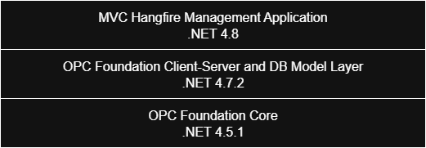
The application provides the next capabilities:
- Start/stop a background job that runs an OPC server, where an XML configuration file tells it which nodes it should manage.
- Start/stop a background job that runs an OPC client (connecting to the server), where an XML configuration file tells it which nodes it should subscribe to in a monitored manner. As soon as it is notified of a change from the server, it dumps the new values ​​for those nodes into the database on the server (with an "idProcess" flag).
- Add a recurring job that executes an OPC client (connecting to the server) where an XML configuration file indicates the server nodes to which it should write values.
- Add a recurring job that executes an OPC client (connecting to the server) where an XML configuration file indicates the server nodes from which it should read values.
- View logs in real time using a text buffer.
NOTE: The XML configuration file used for jobs is the OPC one.
This latest version of the Hangfire server includes:
- Cancellation Tokens to stop jobs in the background.
- All jobs are implemented using the chain of responsibility pattern and can be intercepted using action filters
Basically, the solution creates four jobs:

- First, two BackgroundJob jobs: one for the OPC server (ServerJob) and the other for the client for monitored subscriptions (SubscribeNodesClientJob).
- Then, it creates two more RecurringJob jobs: one to simulate the infrastructure with random values ​​(NodeWriteClientJob) and the other to read the values ​​directly without subscriptions (NodeReadClientJob).
Here the diagram with the solution architecture overvie.
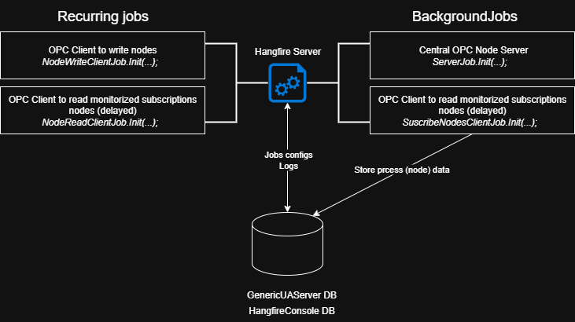

Scope
Hangfire is an open-source library for .NET applications that facilitates the execution of background jobs. It allows you to schedule jobs to run at a specific time, recurringly, or immediately, all without the need for external services, and with an administration panel to monitor their status.
OPC technologies are created to allow information to be easily and securely exchanged between diverse platforms from multiple vendors and to allow seamless integration of those platforms without costly, time-consuming software development. This frees engineering resources to do the more important work of running your business.
Using the MVC application, it is possible to provide a web-accessible UI for managing OPC jobs and viewing logs.

RQ-01 | MVC Hangfire Management Application
This solution contains a standard .NET 4.8 MVC project by which the Hangfire server is managed. It includes two projects, a console application for tests and a windows service project.
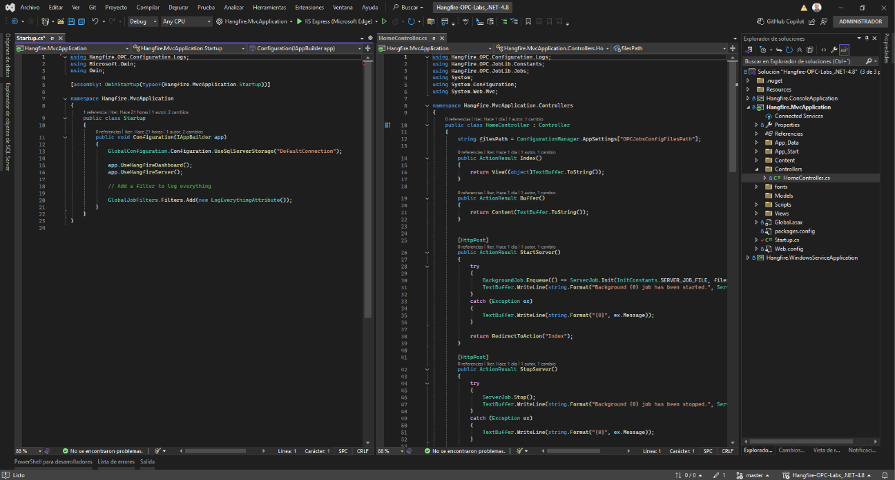
Here the screens of the application:
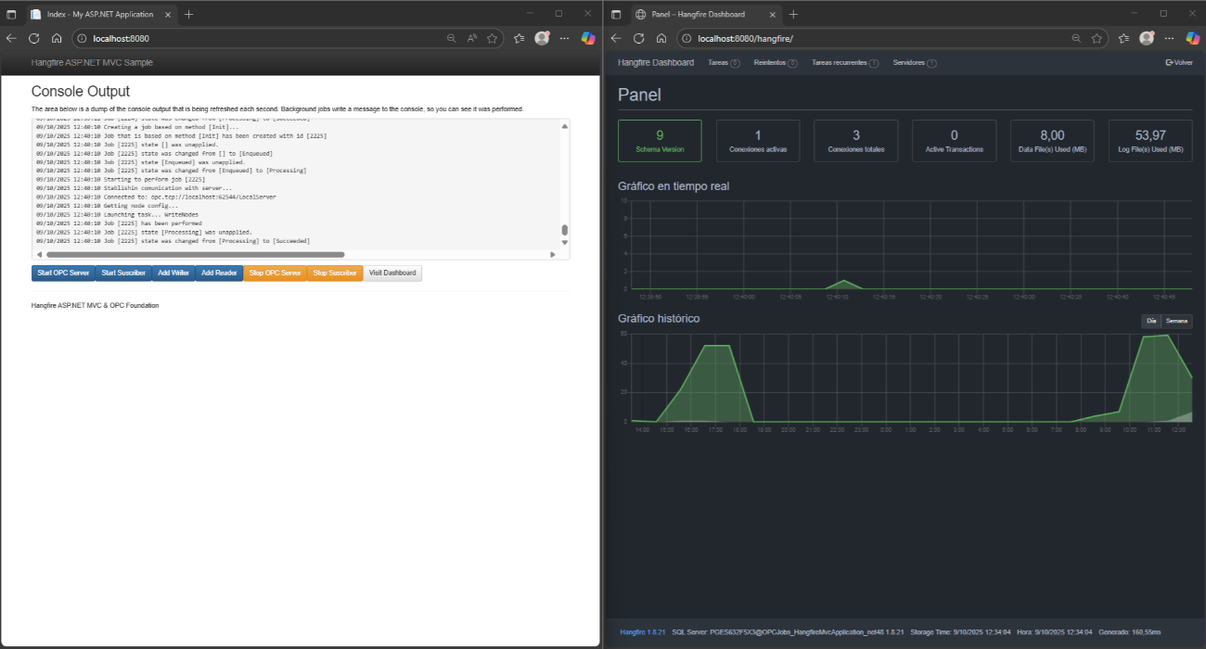
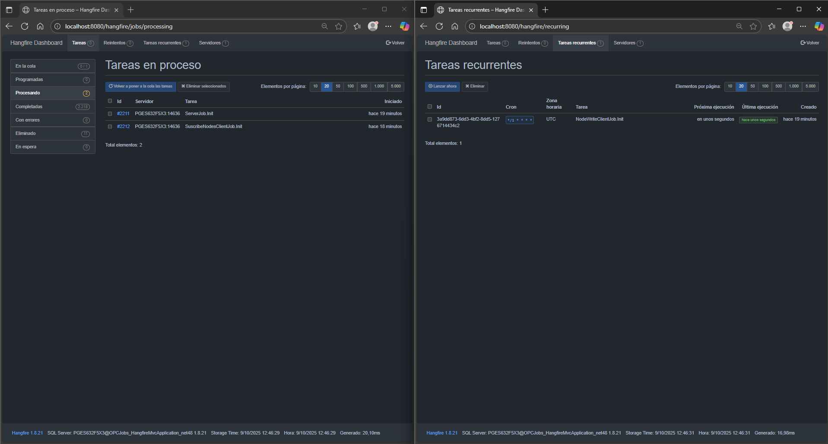

RQ-02 | OPC Foundation Client-Server and DB Model Layer
This solution contains a standard .NET 4.7.2 projects regarding the client-server layer to interact with OPC Foundation together with the database and model projects to store data.
The solution is divided in the next modules or assemblies:
- Client-server layer
  - DB.ModelLib → Database interaction context (EntityFramework)
  - Hangfire.OPC.Configuration → Hangfire default Job configuration
  - Hangfire.OPC.JobLib → Job definitions managed by the Hangfire process
  - OPCFoundation.ClientLib → Opc client procedures and clases to interact with the SDK / Stack
  - OPCFoundation.ServerLib → Opc server procedures and clases to interact with the SDK / Stack
  - OPCFoundation.TaskLib → Tasks managed by the jobs
- Database and model
  - Model.GenericUAServer → GenericUAServer DB model to store the Job process and related data
Note: Hangfire tables are created automatically
  - SQL.GenericUAServer→ Database to store node data

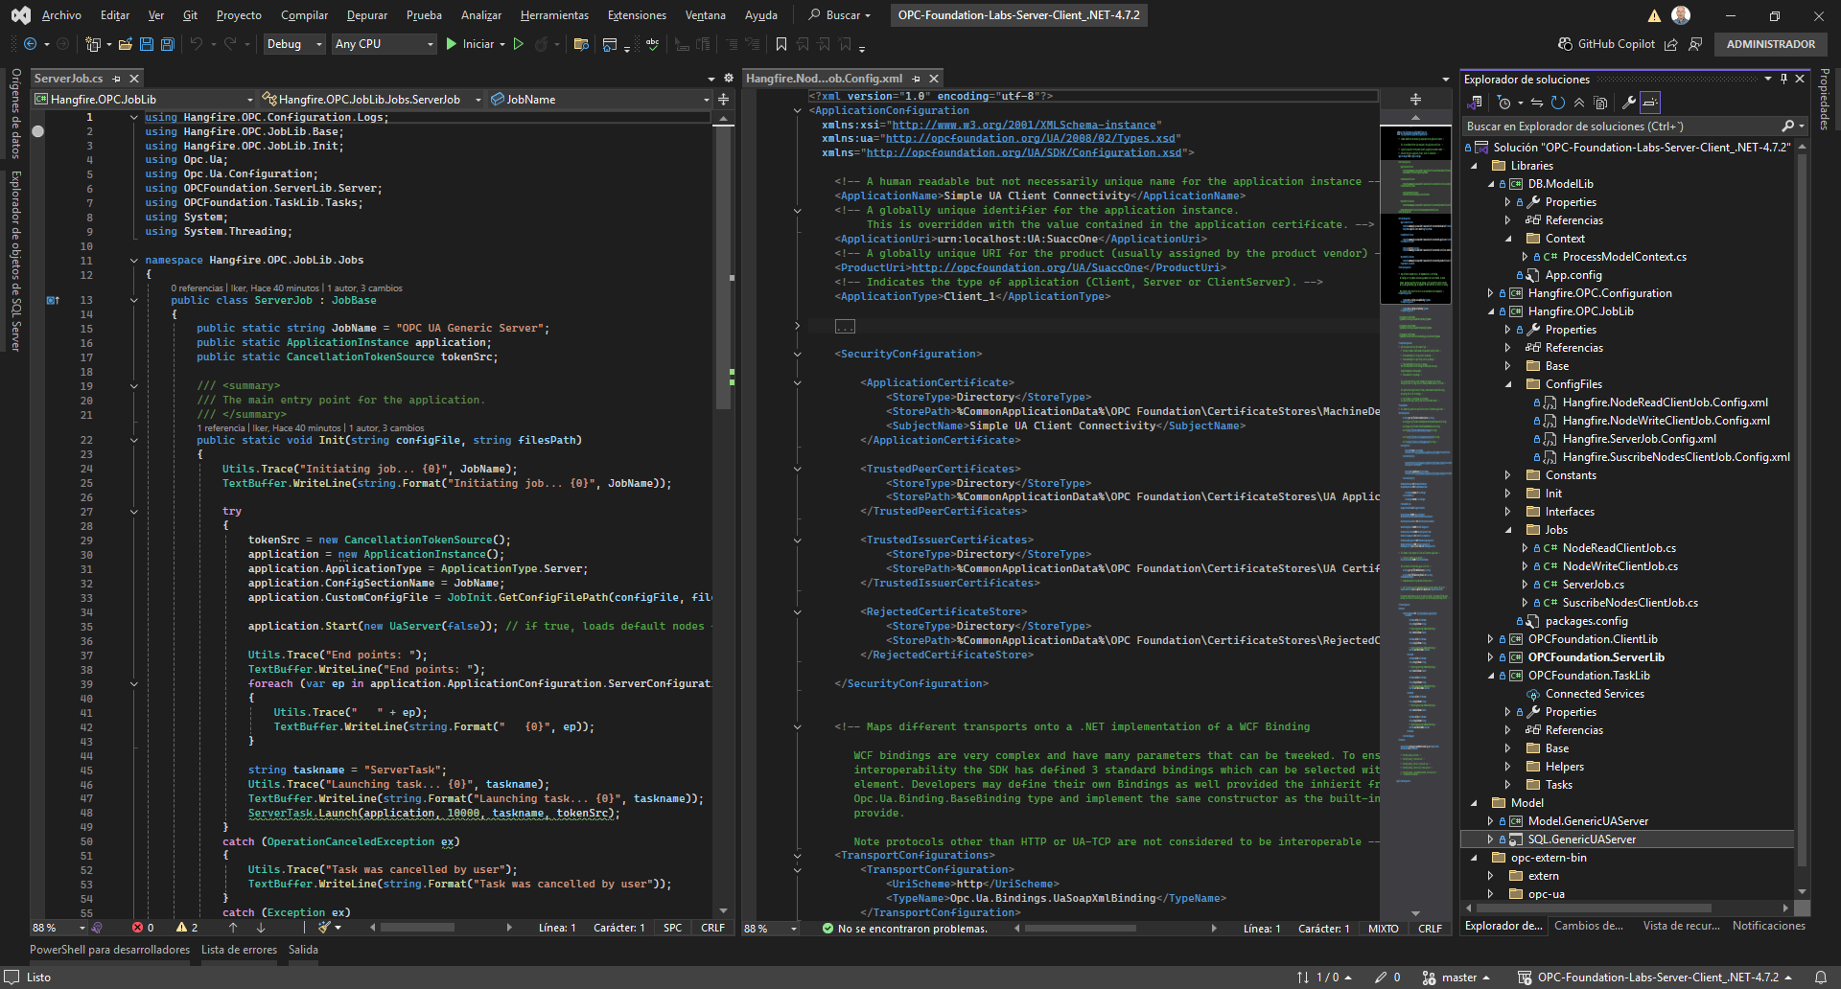
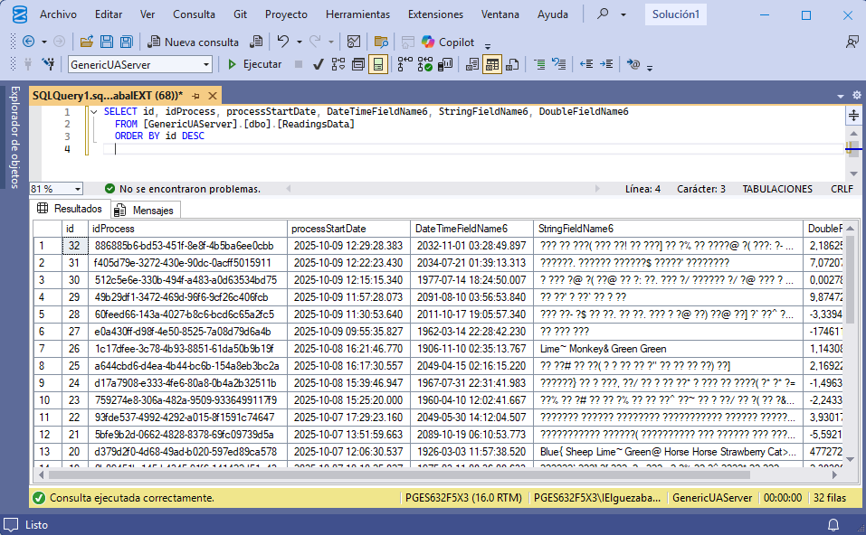
The OPC nodes are defined like this.
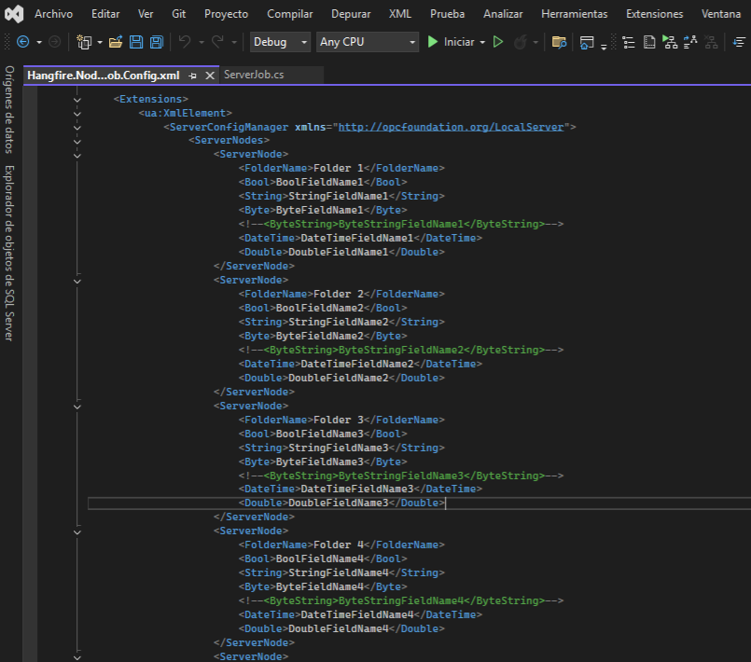

RQ-03 | OPC Foundation Core
This solution contains a standard .NET 4.5.1 projects with the fundamental source code of OPC Foundation.
Contains the SDK and Stack, as we can see in the next image.
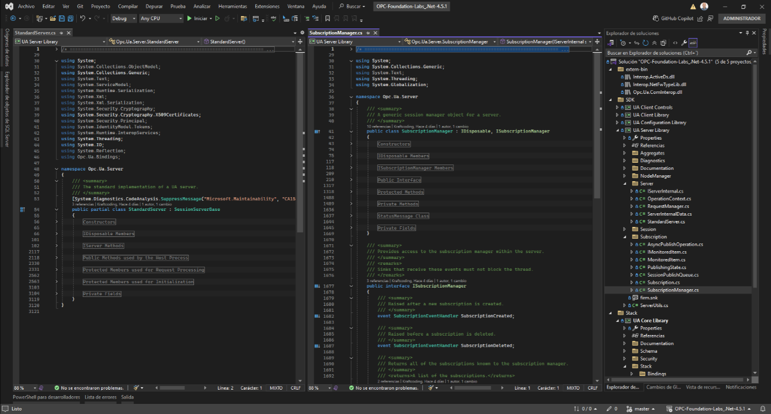

Deployment
To deploy the solution first launch the compare schema.
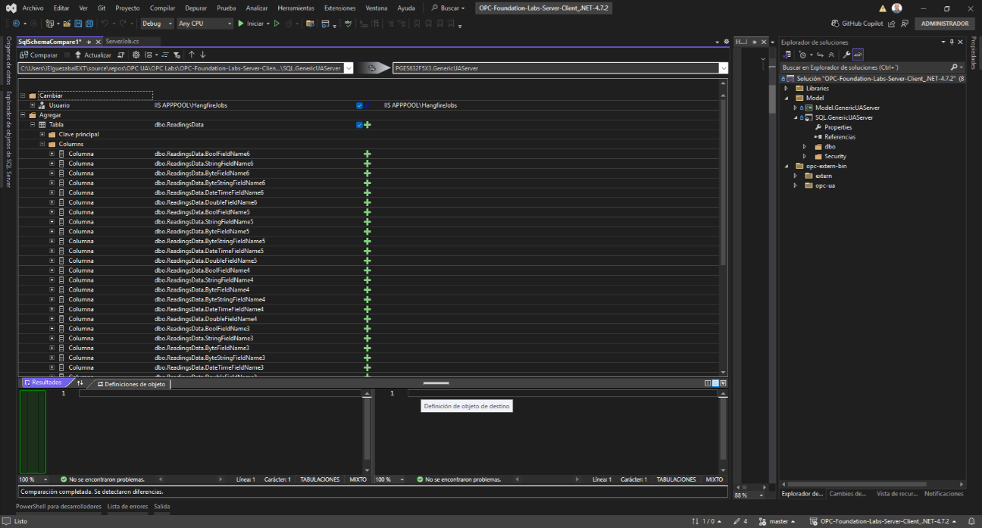
Then publish the MVC application.
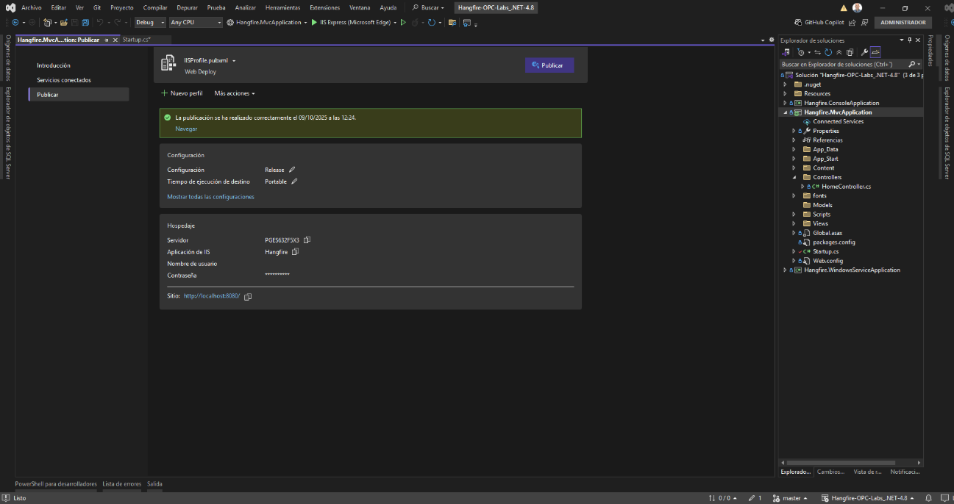
It is needed to give permissions to the IIS app-pool process to use TCP.
- netsh http add urlacl url=http://+:62543/ user=Everyone
- netsh http add urlacl url=http://+:62543/LocalServer/ user=IIS APPPOOL\HangfireJobs
IIS and app-pool configuration should be like this.
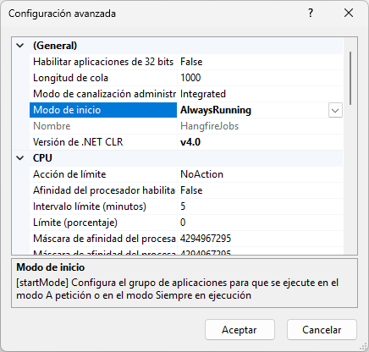

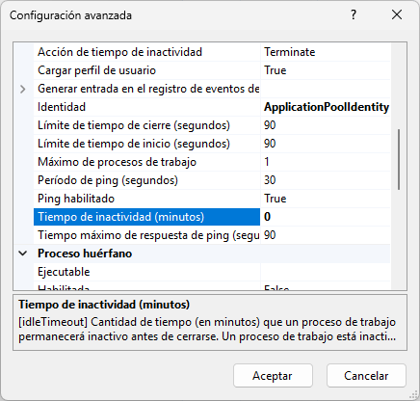
Application Pool Set "Preload Enabled". To set the application pool to "Preload Enabled" in IIS, follow these steps:
- Open the applicationHost.config file located in the %WINDIR%\system32\inetsrv\config\applicationHost.config directory.
- Locate the application pool setting and set preloadEnabled to true.
- Restart IIS to apply the changes.
- Optionally, configure warm-up requests to ensure all necessary components are loaded during the initialization phase.
This configuration allows IIS to send a "fake" request to the application when the associated application pool starts up, ensuring that the application is warmed up before any real traffic is received. This is particularly useful for applications with heavy startup processes, such as those requiring multiple service initializations or database connections.

Software life cycle management
TO DO.

Annexes

Improvements and performance

Hangfire application always running on IIS
Look up if there is any way to ensure that Hangfire application is always running on IIS.

Jobs chain of responsibility pattern
Must be look up if further integration could be attained between the OPC Jobs and Hangfire chain of responsibility patterns.

Additional tools used for testing

UaExpert
For initial steps of development and testing UaExpert client application was used.
